**Max Store Annual Sales Report (2022)**

**Summary**

The Max Store Annual Sales Report (2022) provides a comprehensive analysis of the sales performance for the year 2022. The report aims to understand customer behavior, identify growth opportunities, and propose data-driven strategies to enhance sales in 2023.

**Table of Contents**

* Introduction
* Research Questions
* Data Cleaning
* Data Processing
* Data Analysis
* Key Findings
* Recommendations
* Conclusion
* Contact

**Introduction**

The Max Store Annual Sales Report (2022) offers valuable insights into the sales performance of Max Store throughout the year 2022. This report presents an in-depth analysis of customer trends, sales channels, and regional contributions to sales. The objective is to empower Max Store with data-driven strategies for business growth in 2023.

**Research Questions**

The analysis seeks to answer the following questions:

* Compare Sales and Orders: Use a single chart to compare sales and orders data.
* Gender Comparison: Determine whether men or women made more purchases in 2022.
* Order Status: Identify the different order statuses in 2022.
* Top Sales-Contributing States: List the top 10 states contributing to the sales.
* Age and Gender Relation: Analyze the relation between age and gender based on the number of orders.
* Sales Channel Contribution: Determine which sales channel contributed the most to sales.
* Highest Selling Category: Identify the category with the highest sales.

**Data Processing**

Additional data points were derived using relevant formulas to enhance the dataset's richness. Age groups were categorized into "Senior," "Adult," and "Teenager" categories, and months were extracted from the Date column for further analysis.

**Data Analysis**

Pivot tables were created on different individual sheets to answer the research questions based on the dataset. Additionally, individual Pivot charts were inserted for visualization. The analysis included:

1. Comparison of Sales and Orders: Visualized through the "Sales_&_Orders " chart.

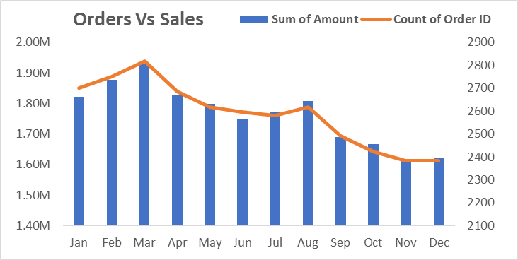

1. Gender Comparison: Analyzed using the "Men_&_Women" chart.

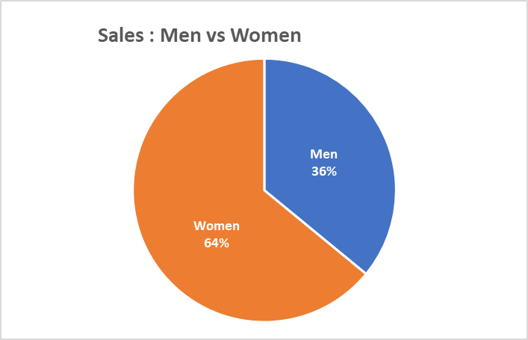

1. Order Status: Displayed using the "Order_Status" chart.
2. Top Sales-Contributing States: Presented in the "Top_5_States" chart.

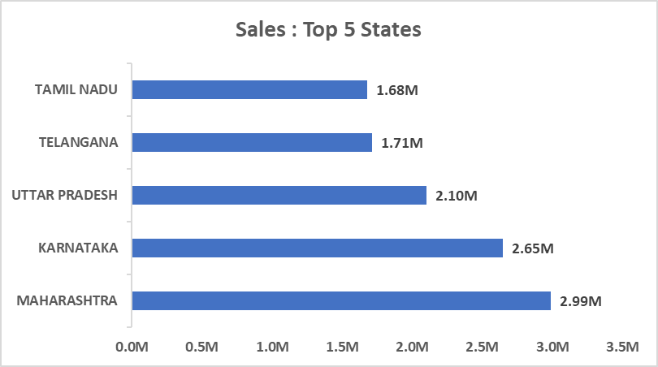

1. Age and Gender Relation: Shown through the "Age_&_Gender" chart.

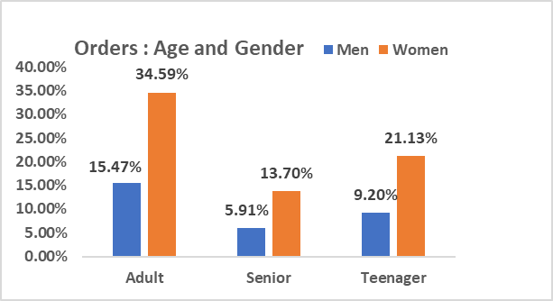

1. Sales Channel Contribution: Visualized in the "Channels_&_Sales" chart.

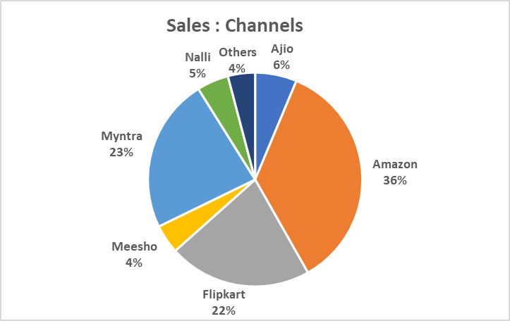

The charts were formatted to make them more appealing and easier to interpret.

**Final Interactive Dashboard with all KPI’s**

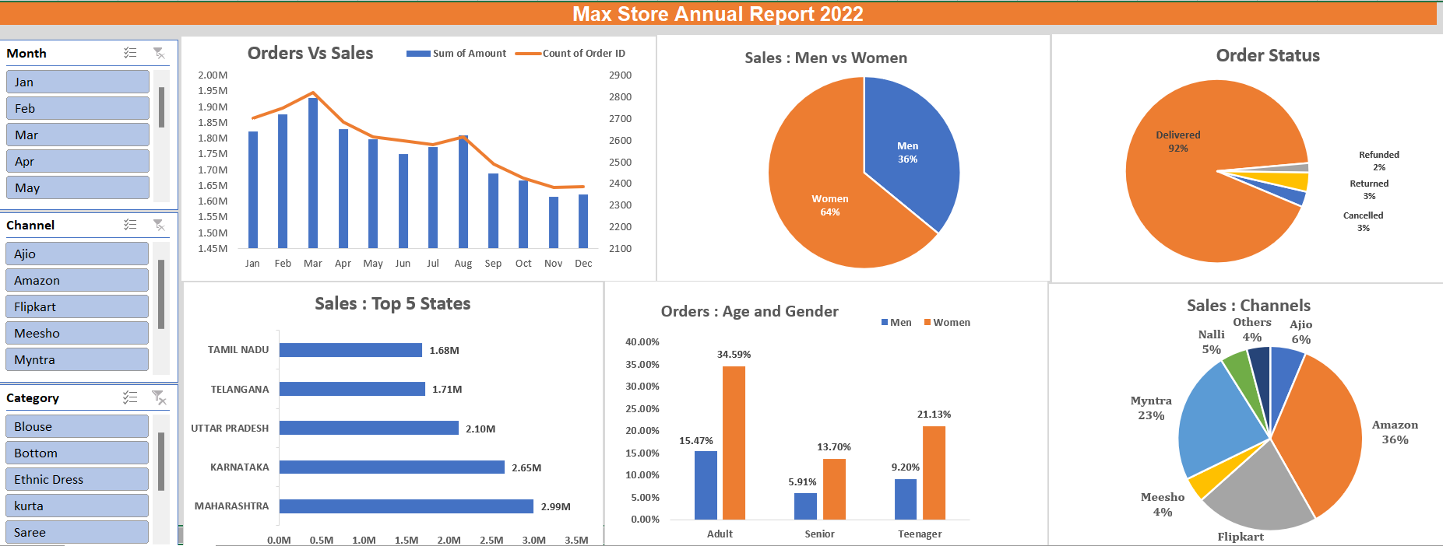

**Key Findings**

* Based on the analysis, the following key findings were discovered:
* Women made more purchases (65%) compared to men in 2022.
* The top contributing states to Max Store sales are Maharashtra, Karnataka, and Uttar Pradesh.
* The adult age group (30-49 years) contributed the most to sales (50%).
* The sales channels with the highest contributions are Amazon, Flipkart, and Myntra (80%).

**Recommendations**

To improve sales performance in 2023, the following recommendations are suggested:

* Target women customers, particularly in the age group of 30-49 years, residing in Maharashtra, Karnataka, and Uttar Pradesh.
* Leverage Amazon, Flipkart, and Myntra, the highest selling channels, with targeted ads, offers, and coupons to increase sales and customer engagement.

**Conclusion**

The Max Store Annual Sales Report (2022) offers valuable insights into the customer behavior and sales performance of Max Store. By leveraging data-driven strategies, Max Store can enhance its business operations, drive growth, and maximize sales in the upcoming year.

**Contact**

For any inquiries or feedback related to this report, please reach out to:

* Name: [Rahul Negi]
* Email: [rahulnegi1555@gmai.com]
* GitHub: [IamRahul15555]
* Contact [9760727648]